To access the new GetIt system, you need to do the following:

1. Close RAD Studio 10.3.2

2. Open the Windows Registry Editor (regedit.exe) and navigate to HKEY_CURRENT_USER\Software\Embarcadero\BDS\20.0\CatalogRepository

3. Edit the value of the ServiceUrl key and enter **https://getit-1032.embarcadero.com**  
See screenshot below for an example:

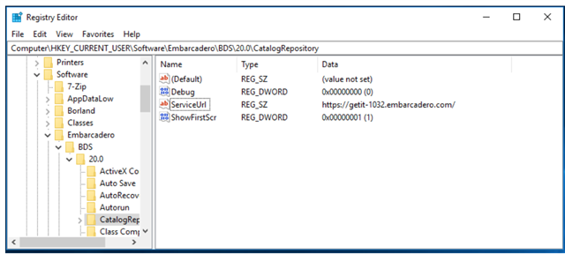

4. Do the same for the key:

HKEY_LOCAL_MACHINE\SOFTWARE\WOW6432Node\Embarcadero\BDS\20.0\CatalogRepository\ServiceUrl

Note: If you are on 32-bit version of Windows, set HKEY_LOCAL_MACHINE\SOFTWARE\Embarcadero\BDS\20.0\CatalogRepository\ServiceUrl

5. Close the Registry editor

6. Restart the RAD Studio IDE and use the GetIt Package Manager (Tools > GetIt Package Manager) as usual

In the GetIt Package Manager, you should see the packages below after following the steps above:

* RAD Server installers for Linux and Windows
* FMX Linux
* Samples
* Boost Library
* FMX and VCL Styles
* Konopka Controls
* Radiant Shapes
* IP*Works
* FastReport VCL
* And other select third party components